- Why protein folding is important?
Protein folding determines the 3D structure of a protein, which is essential for its biological function.
Incorrect folding can cause loss of function, aggregation, and diseases.
- QQplot
A QQ plot (Quantile-Quantile plot) compares the distribution of observed data with a theoretical distribution, usually the normal distribution.
If the points are close to the diagonal line, the data approximately follow that distribution.
- Differences between regression and classification (classification discrete, regression continuos)
Classification is a type of supervised learning used to predict a categorical class label for a new instance. The model learns from a training set, where the correct classes are already known, and then classifies new unlabeled examples. It can be binary classification (2 classes) or multi-class classification (more than 2 classes). (es. Predict blood/no blood).
Regression is also supervised learning, but instead of predicting a category, it predicts a continuous numerical value. It uses one or more predictor variables to learn a mathematical relationship with the outcome (response variable) and then uses this relationship to predict new values. (es predict boold pressure = 124,5)
- Power law distribution
A power-law distribution is a distribution in which a few elements have very high values, while many elements have low values.
In biological networks, for example, a few nodes called hubs have many connections, while most nodes have only a few connections.
- Purpose of BLAST
BLAST is used to compare a biological sequence with sequences in a database and find regions of similarity.
These similarities can help identify related sequences and possible functional or evolutionary relationships.
- What Is a codon? Triplet of nucleotides, codes for a specific amino-acid.
A codon is a sequence of three nucleotides in mRNA.
Each codon specifies a particular amino acid or a stop signal during protein synthesis.
- GA- selection chromosome
In a Genetic Algorithm, chromosomes are evaluated using a fitness function.
Selection gives chromosomes with higher fitness a greater probability of being selected as parents for the next generation.
- Quaternary structure
The quaternary structure is the highest level of protein structure and describes the association of multiple polypeptide chains (subunits).
These subunits interact to form a functional protein complex.
- What does PCA aim to maximise?
PCA finds new directions called principal components.
The first principal component is the direction that captures the maximum variance in the data, and the following components capture as much remaining variance as possible.
- What is the purpose of dimensionality reduction?
Dimensionality reduction aims to reduce the number of features or variables while preserving the most important information.
It makes data simpler to analyse and visualize and can reduce noise and computational complexity.
- How can different types of mutations affect protein creation?
Mutations can change the DNA sequence and therefore affect the protein produced.
They may cause no amino-acid change, an amino-acid substitution, a premature stop codon, or a frameshift, potentially changing protein structure and function.
- What is dynamic programming?
Dynamic programming is a computational method that divides a complex problem into smaller overlapping subproblems.
It stores and reuses their solutions to efficiently find an optimal solution, for example in sequence alignment.
- Supervised learning and unsupervised learning
These are 2 types of machine learning:
Supervised learning learns from labelled data. This means that, during training, each example has both the input and the correct output (label). The system learns the relationship between them and then predicts the output for new data. Classification and regression are supervised learning tasks.
Example: patient data → disease / no disease.

Unsupervised learning learns from unlabelled data, so the correct output is not provided. The system tries to discover hidden patterns, structures, or groups in the data by itself. Example: giving the system information about many patients and asking it to find groups of similar patients. ES. Clustering and dimensionality reduction.

REINFORCEMENT LEARNING: the goal is to create a system (AGENT) that improves its performance based on the interactions with the environment. It takes an ACTION, and receives a REWARD (how good the action is towards the goal to be achieved). We want to maximizes this cumulative reward and we use an exploratory trial-and-error approach.
- Markov chain Clustering (MCL)→ it is used to identify clusters in a network. Starting from the transition matrix, expansion simulates longer random walk in the graph, inflation increases high probabilities and wakens low ones, separating clusters (many connections inside, few connections with other clusters).
ARACNE = algorithm to reconstruct a gene regulatory network (nodes = genes, edges = if two genes manifest same pattern / behaviour, statistical link). We start from a triplet (3 nodes) and compute the mutual information of each pair. The lowest MI indicates the weakest link, and we need to delete this link because probably it is the false link (we want to reduce FP).
- What is a point mutation
A point mutation is a change affecting a single nucleotide in a DNA sequence.
For example, one nucleotide can be substituted by another, potentially changing the corresponding codon and protein.
- How different types of mutation can affect the protein creation
Mutations can affect the protein in different ways: they can cause no amino-acid change (silent), an amino-acid change (missense), or a premature stop codon (nonsense).
Insertions or deletions can also cause a frameshift, changing the reading frame and potentially the whole protein.
- Difference between feature selection and dimensionality reduction
Feature selection chooses a subset of the original features, removing the less useful ones.
Dimensionality reduction, such as PCA, transforms the original features into a smaller set of new features, while preserving as much important information as possible.
- What is the purpose of TopHat?
TopHat is a splicing-aware alignment tool used to map RNA-Seq reads to a reference genome. Sometimes, a read contains the end of one exon and the beginning of another exon. This happens because introns are removed during splicing, so exons are joined together in mature mRNA. However, in the reference genome, the intron is still present between the two exons. TopHat understands this difference and can correctly map the read and identify the exon-exon junction. Alternative splicing can make the mapping more difficult because exons can be joined in different ways. First, TopHat uses Bowtie to map RNA-Seq reads to the reference genome. Reads that map normally are used to identify covered regions, while unmapped reads are set aside. TopHat then uses the mapped regions to generate possible splice junctions between neighboring exons. After that, it takes the unmapped reads and uses a seed-and-extend approach to try to map them across these possible junctions. If a read maps with one part on one exon and another part on another exon, TopHat can identify an exon-exon splice junction.

- Global Alignment usa algoritmo di Needleman-Wunsch
- Local Alignment usa algoritmo di Smith-Waterman.
FORMATI:
- FASTQ→ sequences reads + quality score
- FASTA→ sequences
- BOWTIE → mapping of large set of short reads to ref. genome (short-read- aligner)
- TopHat→ usa Bowtie per mapping di milions of reads, but is splicing aware aligner, aware of spliced junctions between 2 exons, starting from acceptor /donator splicing sites, create possible candidate for splicing junctions.
- SAM/BAM→ alignments format
- SAMtools→ post-processing di SAM /BAM
- GFF / BED→ genomic annotation / features
- BEDtools→ overlaps, coverage, genomic operations
- SeqMonq→ analysis and visualization of mapped sequencing data.

ML MAIN CONCEPTS
CLUSTERING = we divide our data into clusters based on the maximization of SIMILARITY for samples in the same cluser and the minimization of SIMILARITY for samples in different clusters.
DIMENSIONALITY REDUCTION = reduce the feature space, retaining the most relevant information, and removing noise. Usually a pre-processing step. We project the input samples into a new lower-dimensional space.
CLASS = set of objects sharing properties. Identifed by a categorical identifier (label), and prototype to select an object representative for the class.
Stratified sampling → we want to maintain the class proportions in the selected sets.
A naïve classifier always predicts the most common (most prevalent) class, without using the predictor variables. For example, if 80% of patients are healthy and 20% are sick, the naïve classifier predicts “healthy” for everyone, obtaining 80% accuracy. We use this as a benchmark: normally, we want our ML model to perform better than the naïve rule
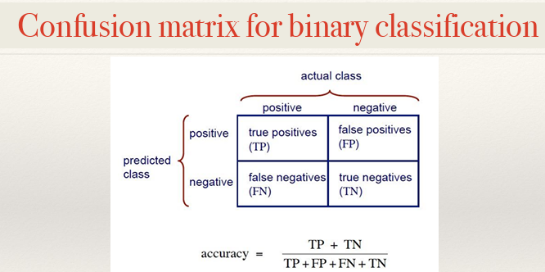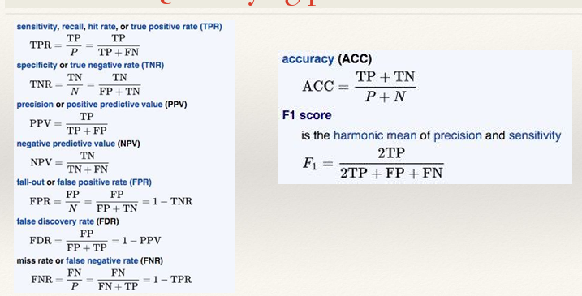
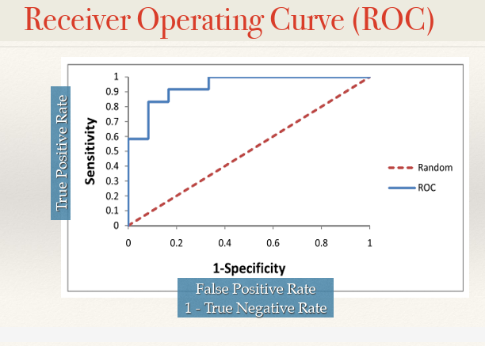
When we have rare class, unbalanced dataset, accuracy is not good.
PRECISION = how useful the results are
RECALL = how complete the result are
Precision, Recall, F1 score can be used both with balanced/unbalanced dataset.

SANGER METHOD
FIRST GENERATION→ leggo un frammento alla volta
SECOND GENERATION→ leggo tanti frammenti insieme
GOAL = first generation sequencing→ determine the exact order of the nucleotides in DNA (order of nitrogenous base: A,T,C,G).
- We start from a DNA fragment that we want to sequence. First it is inserted into a PLASMID (small circular DNA molecule) used as a vector and replicated by bacteria, we obtain many identical copies of this DNA fragment.
- Using this copies as template DNA. We start with one template DNA. Primer (DNA sequence) binds to it and gives DNA polymerase a starting point. Then DNA polymerase starts building new strand of DNA using normal nucleotides d NTP. Sometimes it is added the TERMINATOR (dd NTP) that stop the synthesis. It can happen at different positions, so we obtain fragments of different length.
- Fragments separated by electrophoresis.
- Each ddntp has a fluorescent colour so the machine reads the color and rebuild the sequence (from shortest to longest). Thanks to the colour it identifies the bases (base calling).
SANGER directly sequences the DNA, not aminoacids. But from the DNA sequence we can predict the aminoacids sequence. To discover amino acids in protein we use Edman degradation / mass spectrometry.
ERROR RATE 1%--> to reduce use redundancy/coverage.
SANGER can only read 500-1000 base pairs, not so good for the whole genome that contains millions of pairs. So fragment the genome, sequence the fragments and assemble them.
2 approaches:
- HIERARCHICAL SEQUENCING→ In the hierarchical approach, we first organize the genome into large DNA fragments. Then, we create a genomic library, which is a collection of overlapping cloned DNA fragments. We determine the correct order of these fragments and create a physical map of the genome. Finally, each large fragment is sequenced separately. This approach is accurate and organized, but it is slower than the shotgun approach because we have to map and order the fragments before sequencing them.
- SHOTGUN APPROACH
In the shotgun approach, the whole genome is randomly broken into many DNA fragments. These fragments are sequenced, and then the reads are assembled computationally by looking for overlapping sequences. Overlapping reads are joined together to form a CONTIG. Sometimes two contigs are separated by a repetitive sequence, so we do not know whether they are connected. To solve this problem, paired-end sequencing can be useful because we sequence both ends of a larger DNA fragment. If the two ends map to two different contigs, we can infer that these contigs are connected and organize them into a SCAFFOLD. Finally, redundancy is important: if a difference appears in only one read, it is probably a sequencing error, while if the same difference appears in many independent reads, it is more likely to be a real mutation.
During genome sequencing, the genome is fragmented and multiple overlapping fragments are used to obtain high coverage. However, in cloning-based approaches, some DNA fragments can be difficult to clone, for example because of their structure or because they are toxic to the host cell. Therefore, these fragments may be missing from the genomic library and cannot be sequenced, leaving gaps in the final genome sequence. This can happen even when the overall coverage is high.

ILLUMINA (multiplexing)
Next generation / second generation (massevly parallel sequencing→ many fragments contemporary sequenced). Differently from SANGER we don’t clone the DNA fragment with plasmid.
We start from a blood sample, extract DNA and break it into fragments. We don’t clone this fragment. At the extremities we add well-known sequences (P5, P7)→ P5---unknown sequence—P7. We transfer the fragment in the flow cell (solid surface), and the adaptors P5 / P7 attach to the oligonucleotide covalently attached (HYBRIDIZATION). After that we have one unified DNA molecules, thanks to PCR (bridge amplification) in solid surface we replicate it and we use DNA polymerase with terminator (fluorescent colour) to attach to complementary nucleoutides. Now with base calling we identify the base and sequence them. We can remove terminators because they are REVERSABLE.
After a DNA fragment is sequenced we can RESEQUENCING (align reads to REFERENCE GENOME), DE NOVO ASSEMBLY (finding some overlap between reads because we don’t have REF.GENOME).
RECAP
TIPI RNA
- Messanger RNA (m RNA) → carries the genetic information from DNA to RIBOSOME. It contains the sequence that will be read during translation
- Ribosomia RNA (r RNA) → structural / functional component of ribosome
- Transfer RNA (t RNA) → during translation brings aminoacids to the ribosome.
RIBOSOME = complex made of r RNA + proteins involved in protein synthesis. Its r RNA catalyzes the formation of peptide bonds between amino acids to build a protein.
Transcription is the process in which the information in DNA is copied into RNA. It starts at a DNA region called the promoter, which can contain specific sequences such as the TATA box. The TATA box is not a protein, but a DNA sequence that can be recognized by transcription factors (TFs). Transcription factors are DNA-binding proteins that help recruit and correctly position RNA polymerase at the promoter. RNA polymerase is the enzyme that synthesizes the RNA molecule: it reads the DNA template strand in the 3′→5′ direction and builds the RNA in the 5′→3′ direction by adding complementary RNA nucleotides. The specific DNA sequences to which the transcription factors bind are called regulatory elements (PROMOTER + ENHANCER).
A protein domain is a specific part of a protein that has its own structure and function. A single protein can contain different domains, and each domain can perform a different function or interact with other molecules. If two interacting domains are in the same protein, they are already physically close. However, if the two domains are located in two different proteins, the two proteins must come close and physically interact. In this way, the two domains can remain close to each other and preserve the same functional interaction.
VBT = Virtual Body Tracking
To track the movements of our body, we can use IMU (wearable inertial sensors to detect rotation / acceleration ), EMG (electric activity of muscles), MOCAP (motion capture→ + used). → we user markers on the human body and cameras to detect them, from different point of view.
Triangulation is a technique used in Motion Capture (MoCap) to reconstruct the 3D position of a marker. The same marker is observed by two or more cameras from different points of view. Each camera gives a 2D position, and by combining these different views, triangulation calculates the 3D coordinates (x, y, z) of the marker. By doing this for many markers, we can reconstruct the movement of the body.
An RGB-D (RGB-Depth) camera is different because, in addition to a normal RGB image (colour information), it also provides depth information, meaning the distance of objects from the camera. So, for each point, we have not only its position in the image but also information about its distance from the camera. This makes it possible to reconstruct body position in 3D, often without physical markers.
Finally, a 3D Pose Estimation Network is an AI/deep-learning model that estimates the 3D position of body joints, such as shoulders, elbows, knees and ankles, from image or depth data. The final output is a 3D skeleton representing the person's pose.
ML VS DL
DL requires much more data but reduces the user dependency, has a better generalization capability, it is less interpretable and requires higher computational power.
MICROARRAY
In microarray analysis, we measure the expression levels of genes (many genes at the same time). If we have replicates, meaning that the experiment is repeated several times, we can use statistical tests to understand if a difference in gene expression is real or simply due to random variability. A statistical test starts from a null hypothesis, which usually says that there is no significant difference between the groups. For example, a t-test can compare two groups, while ANOVA (Analysis of Variance) can compare the differences between multiple groups. Therefore, the statement in the question is TRUE: when replicated microarray data are available, statistical tests such as t-tests and ANOVA can be used to determine whether an observed difference is statistically significant.
A DNA microarray is a technique used to study the expression of thousands of genes at the same time. The microarray is a solid surface containing thousands of immobilized DNA probes, often short sequences called oligonucleotides. Each probe is designed to recognize a specific complementary sequence. We extract mRNA from the biological sample and convert it into cDNA, which is usually fluorescently labelled. Then, the cDNA is added to the microarray and hybridizes with complementary DNA probes. The intensity of the signal can then be used to estimate the expression level of the corresponding gene. Therefore, oligonucleotides do interact with complementary cDNA: this hybridization is the fundamental principle of a microarray. If a gene is highly expressed, it produces a large amount of mRNA. The mRNA is converted into cDNA, so we obtain many cDNA molecules corresponding to that gene. These cDNAs hybridize with the complementary probes on the microarray, producing a stronger signal. Therefore, a stronger signal generally indicates a higher level of gene expression.
Sequence comparison is about motifs, conservation and evolution — not the physical/chemical properties of molecules.
REM
Usually we have rapid eyes movements, dreams, very active brain + skeletal muscle atonia. If we are in DISSOCIATED STATUS REM→ it is characterized by lack of muscle atonia.
Short read lengths make assembly and alignment across repetitive/complex regions much harder. So the length of the reads is important
Reverse engineering is the process of analyzing an existing system to understand how it works and to identify the relationships between its different components.
Top-down approach: we start from the whole system and from observed data, and then we try to identify the relationships between its individual parts. For example, we observe the behavior of a complete biological network and try to understand how genes or proteins interact.
Bottom-up approach: we start from the individual components and from what we already know about them, and then we combine these components to understand or build the whole system.
Distance-based methods are used to construct phylogenetic trees. First, we calculate the evolutionary distance between each pair of taxa (organisms) and organize these values in a distance matrix. Then, an algorithm uses this matrix to construct the phylogenetic tree, generally grouping the most similar taxa together. Examples of distance-based algorithms are UPGMA and Neighbor-Joining. Therefore, statement C is untrue because clustering is not the only algorithm used for distance-based tree construction.
IT IS VERY SIMILAR TO HIERARCHICAL CLUSTERING!!! hierarchical clustering mainly groups similar data, while a phylogenetic tree aims to represent evolutionary relationships.

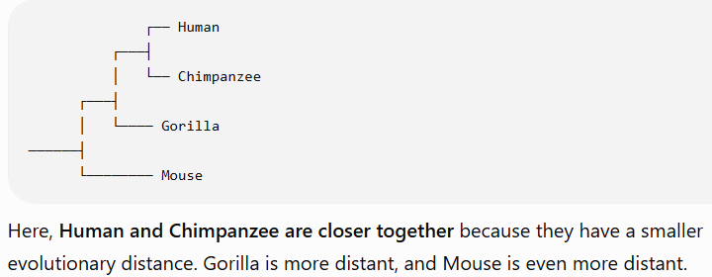
If two sequences have a significant similarity, it is very unlikely that this similarity occurred randomly. Instead, the similarity suggests that the two sequences may have a common evolutionary origin.
HIERARCHICAL CLUSTERING
Hierarchical clustering is a method used to group similar data, for example genes with similar gene expression profiles. Similar genes are placed close together in the leaves of the tree, while dissimilar genes are placed farther apart. The branching pattern (modo in cui I rami di un dendrogramma si collegano tra loro) of the tree shows the relationships between different genes or groups of genes: closer branches indicate a higher degree of similarity. The final result is a tree-like structure called a dendrogram, which represents the hierarchy and relative relatedness of the different groups. Hierarchical clustering is also similar to distance-based phylogenetic tree building, because both methods use distances or similarities to progressively group related elements.
RNA PARTICULAR CASE
HAIRPIN LOOP→ A hairpin loop is a secondary structure of RNA (usually it is single-stranded). It is formed when complementary bases of the same RNA molecule pair with each other, creating a base-paired region called the stem. The unpaired single-stranded region at the end forms the loop.
NEURAL NETWORK
A Self-Organizing Map, or SOM, is an unsupervised neural network used for clustering. We first define a number of nodes, and the initial organization is random. During training, the network changes its organization so that similar data points are placed close together. In this sense, SOM is similar to K-means because both methods group similar data. However, SOM is based on a neural network.
Cross-individual transfer learning means training a neural network on one patient and partially reusing the learned model for another patient. Some information learned from Patient 1 can be transferred to Patient 2, but the model may need to be adapted because different individuals have different characteristics. This can reduce the amount of new training needed for Patient 2.
A Boolean network is a simple model of a dynamic network in which each node can assume only two values: ON = 1 or OFF = 0. These values can change over time according to Boolean rules until the network reaches a stable state called an attractor.
A Petri Net is a mathematical model used to represent and simulate a dynamic system, in which events or transitions occur and the state of the system changes over time. Petri Nets can also have stochastic variants, which include randomness or probabilities.
Proteins can contain specific amino acid sequences that work as an address, indicating where the protein must be transported in the cell to perform its function. These sequences are called sorting signals or signal sequences.(PROTEIN SORTING/protein TARGETING)
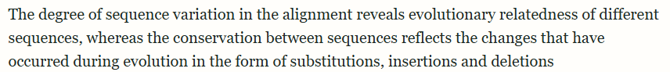
In a linear system, the behavior of the whole system can be understood from the behavior of its individual parts. In a complex or non-linear system, the components interact with each other and these interactions can produce new properties or functionalities that are not present in the individual components. These are called emergent properties.
STRUCTURE OF A GENE
Old definition: 1 GENE→ 1 PROTEIN
But now we know that starting from pre m RNA we can combine exons in different ways thanks to ALTERNATIVE SPLICING and for this reason we obtain different PROTEIN ISOFORMS, different functional products.
“A gene is a union of genomic sequences encoding a coherent set of potentially overlapping functional products”
First we start with the gene in DNA:
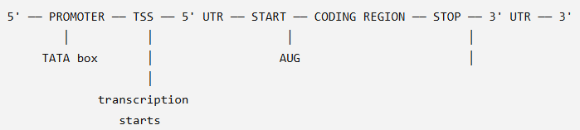
The promoter is the regulatory elements, it can contain TATA box (DNA sequences to help transcription factors to recruit and position RNA polymerase). The promoter is NOT transcribed. TSS = Transcription starting site→ where the transcription starts.
RNA polymerase starts from TSS to read the template DNA strand and build RNA strand: we obtain PRE-mRNA →
5' ── 5'UTR ── EXON ── INTRON ── EXON ── INTRON ── EXON ── 3'UTR ── 3'
It contains INTRONS, removed after splicing, we obtain mature m RNA: we add 5’ CAP (5’) and poly-A tail at the end (AAA). 5' CAP ── EXON ───── EXON ───── EXON ── POLY-A TAIL
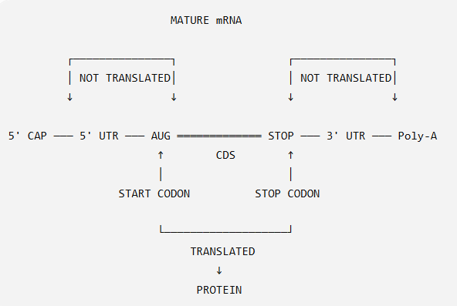
5’UTR and 3’UTR are transcribed but not translated, only the coding sequence (START CODON- STOP CODON) is translated into protein.
START CODON = AUG
PARKINSON:
Core motor symptoms → bradykinesia (slow of movements), tremor, rigidity, postural instability
Motor complications → dyskinesia (involutary abnormal movements), freezing of gait (tende a tenere il più possible il piede a terra perché non riesce a muoversi)
A box plot displays the median, quartiles and outliers of a distribution.

